Project Design Phase-II

TechnologyStack(Architecture&Stack)

|  |  |
| --- | --- |
| NM ID | 76860632B2D43EFBE814FEC16F13E5E4 |
| ProjectName | How To Add Google Analytics To A Website |

# TechnicalArchitecture:

TheDeliverableshallincludethearchitecturaldiagramasbelowandtheinformationasperthetable1&table2

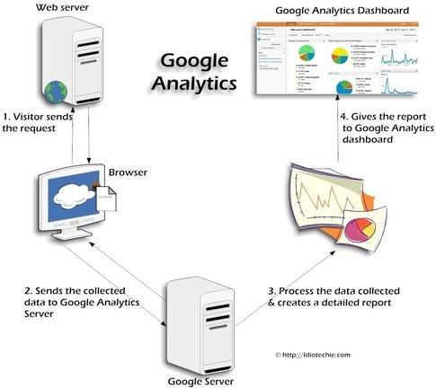

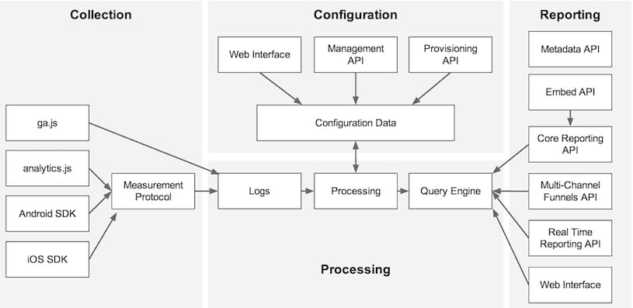

# Table-1:Components&Technologies:

|  |  |  |  |
| --- | --- | --- | --- |
| **S.No** | **Component** | **Description** | **Technology** |
| 1. | UserInterface | Integrate Google Analytics with Blogspot using JavaScript tracking code for real-time data tracking and analysis.. | JavaScript |

|  |  |  |  |
| --- | --- | --- | --- |
| 2. | ApplicationLogic-1 | Use event tracking to monitor user interactions on your Blogspot blog and send data to Google Analytics via JavaScript for improved insights. | JavaScript |
| 3. | ApplicationLogic-2 | Implement custom dimensions and metrics in Google Analytics for Blogspot to track specific user behaviors and attributes through JavaScript integration. | JavaScript integration |
| 4. | ApplicationLogic-3 | Utilize URL parameters to track marketing campaigns and referral sources in Google Analytics for your Blogspot blog through JavaScript code. | JavaScript code. |
| 5. | Database | integrate Google Analytics with Blogspot using JavaScript tracking code for comprehensive website data analysis. | data analysis. |
| 6. | Cloud Database | Leverage Google Cloud Firestore as a scalable cloud database for Google Analytics data integration with Blogspot. | data integration with Blogspot. |
| 7. | FileStorage | You can integrate Google Analytics with Blogspot using JavaScript tracking code for data storage and analysis.. | JavaScript tracking code |
| 8. | ExternalAPI-1 | Google Analytics on Blogspot can't directly access external APIs to gather data, but you can use Google Tag Manager to add custom tracking solutions and integrate with external APIs for advanced analytics. | Googlelocation |
| 9. | ExternalAPI-2 | integrate the Google Analytics API into Blogspot using JavaScript for enhanced website analytics. | Googlelocation |
| 10. | MachineLearningModel | Implement machine learning models in Google Analytics data analysis for Blogspot websites using Python and TensorFlow. . | Python |
| 11. | Infrastructure(Server/Cloud) | Set up a scalable cloud infrastructure for Google Analytics integration with Blogspot using AWS (Amazon Web Services) for efficient data processing and storage. | Amazon Web Services |

|  |  |  |  |
| --- | --- | --- | --- |
| **S.No** | **Characteristics** | **Description** | **Technology** |
| 1. | Open-SourceFrameworks | You can use the "Blogger Google Analytics" open-source framework for integrating Google Analytics into your Blogspot blog, using JavaScript and HTML. | Blogger Google Analytics |

|  |  |  |  |
| --- | --- | --- | --- |
| 2. | SecurityImplementations | Implement security for Google Analytics on Blogspot using HTTPS (TLS/SSL) to encrypt data transmission and proper access controls to protect user data . | TLS/SSL |
| 3. | ScalableArchitecture | Design a scalable architecture for Google Analytics on Blogspot using cloud-based serverless functions (e.g., AWS Lambda or Google Cloud Functions) to handle tracking and analytics requests. | AWS Lambda or Google Cloud Functio |
| 4. | Availability | Ensure high availability for Google Analytics on Blogspot by leveraging a distributed architecture and content delivery networks (CDNs) to minimize downtime and improve responsiveness. . | CDNs |

|  |  |  |  |
| --- | --- | --- | --- |
| **S.No** | **Characteristics** | **Description** | **Technology** |
| 5. | Performance | Optimize performance for Google Analytics on Blogspot by using asynchronous loading of tracking scripts and leveraging browser caching for faster data retrieval. | blogspot |

**Table-2:ApplicationCharacteristi**